Results
The ABC RELM CV was the final proposed model in this project. Testing and comparisons across multiple models were conducted to evaluate performance. The experiment was designed as a 5-fold cross-validation evaluated across 50 random seeds to account for the high variance caused by the Extreme Learning Machine's (ELM) random initialization. It is worth noting that all ELM variants utilized a hidden layer size of 40, while all RELM variants utilized a hidden layer size of 30 with $λ=$ $2^{-2.5}$ during testing. Additionally, all ABC variants utilized a population size of 80, a limit of 40, and 120 iterations, employing Algorithm 3 for employed bees and Algorithm 2 for scout bees.
Statistical tests were conducted to compare model stability across random initializations and generalization ability across data distributions. Statistical significance is denoted using asterisks and +/- notation: * for p<0.05, ** for p<0.01, and *** for p<0.001. The +/- signs are positioned above the compared baseline models, where a '+' indicates that the proposed model performed significantly better than the baseline, and a '-' indicates that the proposed model performed significantly worse. Furthermore, orange symbols (asterisks and +/- signs) denote the results of the Wilcoxon signed-rank test, while blue symbols denote the results of the paired t-test.
Model stability was evaluated using the Lower Confidence Bound (LCB) results from the 5-fold cross-validation for each individual seed via the Wilcoxon signed-rank test. (This step was excluded for convex optimization models such as LRC and SVC). Model generalization was evaluated using the fold results—averaged across all seeds to mitigate initialization variance—through a paired t-test, which included all models. Finally, a Bayesian evaluation was conducted on several representative models.
The first phase of testing compared the proposed model against within-family models. First, the proposed model was compared against the base models: ELM, RELM, and RELM CE. The results demonstrated that the proposed model achieved significantly better stability across seeds compared to RELM and RELM CE, and significantly better data generalization compared to RELM CE. Second, it was compared to the ABC-optimized models: ABC ELM, ABC RELM, and ABC RELM CE. The proposed model demonstrated comparable performance to other ABC RELM-based variants; notably, while these three models showed slight mean improvements over ABC ELM without reaching statistical significance.
The second phase compared the proposed model against baseline models from the scikit-learn library. First, the proposed model was compared to stochastic and ensemble models (MLP, RF, HGBC, and Bagging LRC), resulting in significantly better stability compared to MLP, HGBC, and Bagging LRC, but no significant difference in generalization. Second, the proposed model was compared to deterministic models (LRC and SVC), revealing that the proposed model demonstrated significantly weaker data generalization compared to LRC.
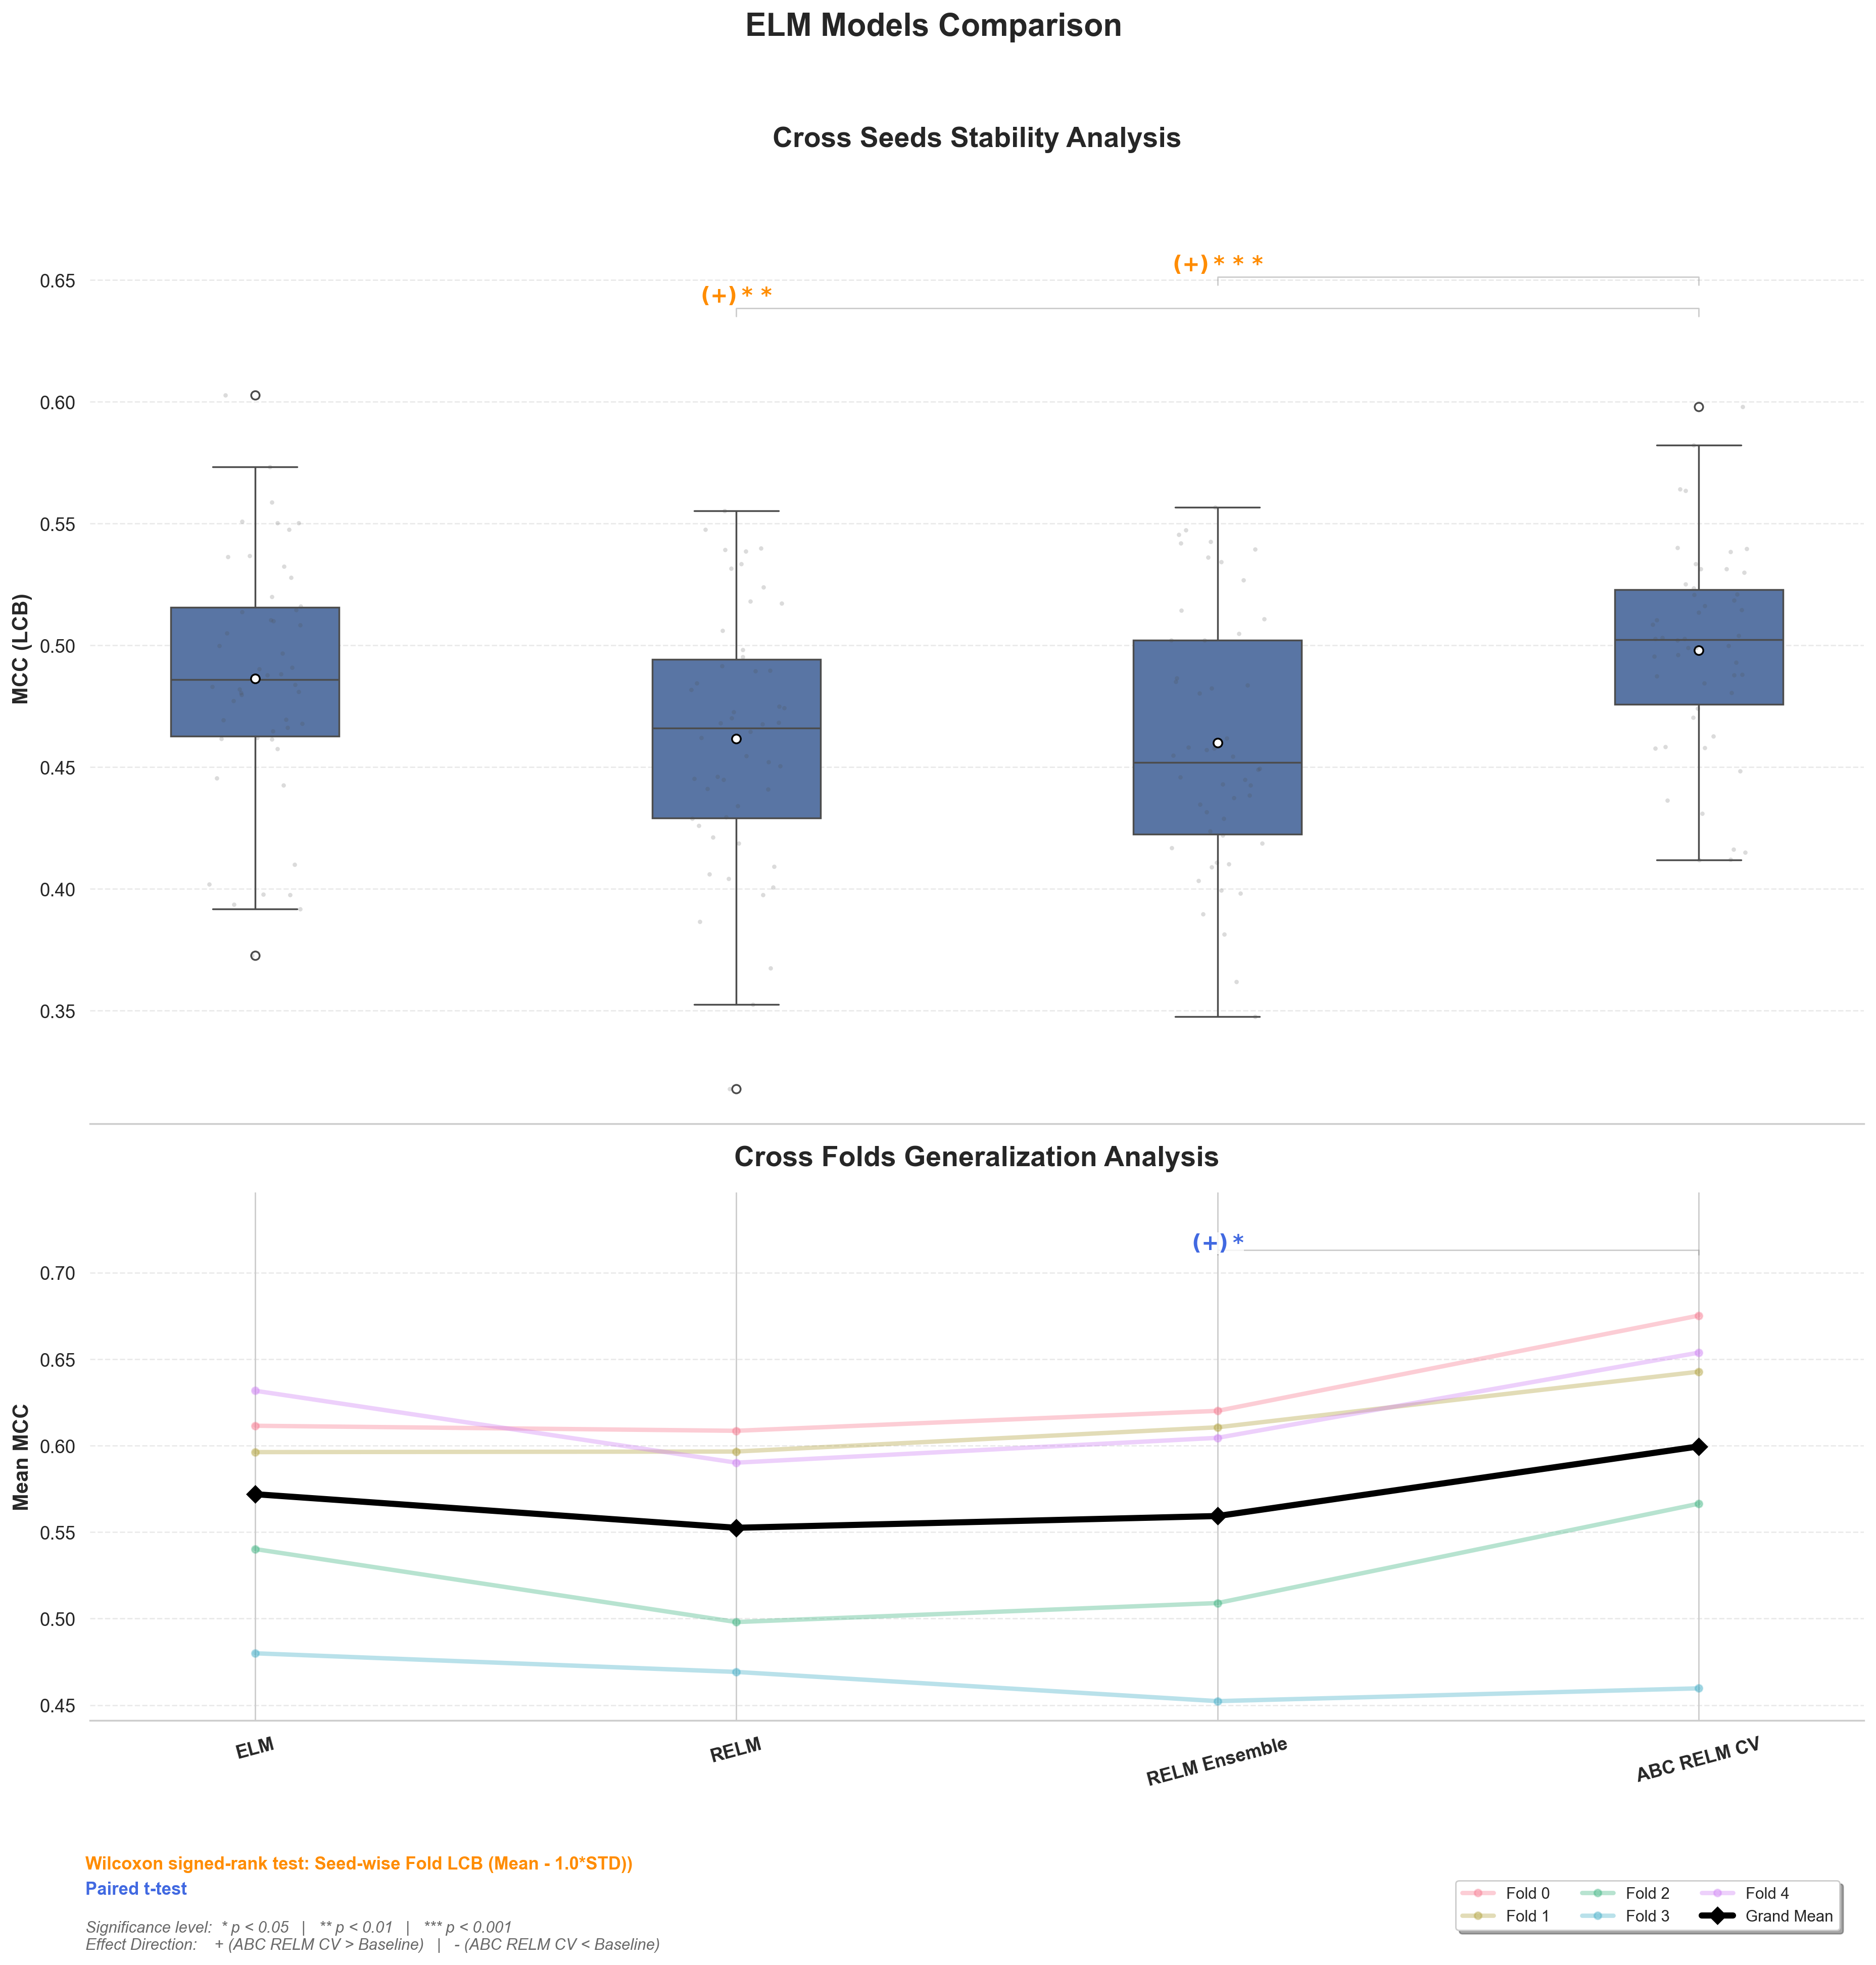
Model | Accuracy | F1-Score | MCC | P test | Direction
Stability (Metrics LCB with Wilcoxon signed-rank test)
ELM | 0.7396 ± 0.0246 | 0.7106 ± 0.0288 | 0.4864 ± 0.0504 | 0.2219 | 0
RELM | 0.7279 ± 0.0263 | 0.7013 ± 0.0316 | 0.4616 ± 0.0528 | 0.0014 | +1
RELM Ensemble | 0.7273 ± 0.0262 | 0.7002 ± 0.0307 | 0.4601 ± 0.0528 | 0.0008 | +1
ABC RELM CV | 0.7453 ± 0.0203 | 0.7169 ± 0.0225 | 0.4980 ± 0.0421 | - | -
Generalization (Metrics with paired t-test)
ELM | 0.7823 ± 0.0310 | 0.7612 ± 0.0365 | 0.5720 ± 0.0616 | 0.3655 | 0
RELM | 0.7733 ± 0.0317 | 0.7532 ± 0.0347 | 0.5525 ± 0.0641 | 0.0982 | 0
RELM Ensemble | 0.7769 ± 0.0376 | 0.7571 ± 0.0437 | 0.5593 ± 0.0748 | 0.0375 | +1
ABC RELM CV | 0.7956 ± 0.0437 | 0.7741 ± 0.0491 | 0.5996 ± 0.0883 | - | -
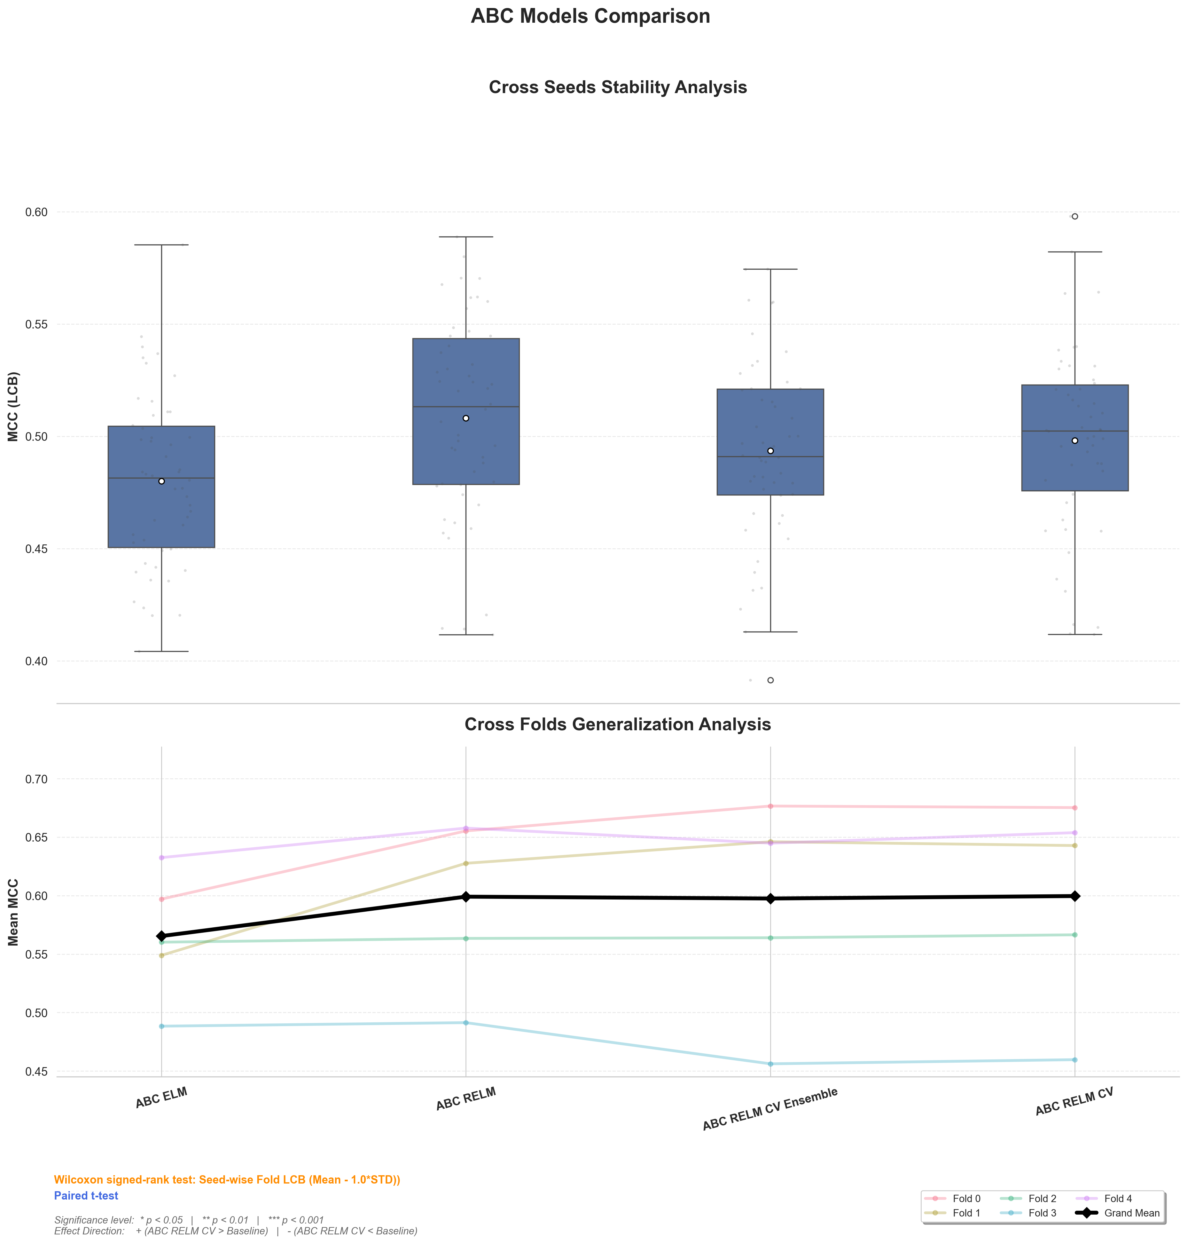
Model | Accuracy | F1-Score | MCC | P test | Direction
Stability (Metrics LCB with Wilcoxon signed-rank test)
ABC ELM | 0.7366 ± 0.0197 | 0.7078 ± 0.0256 | 0.4800 ± 0.0385 | 0.1011 | 0
ABC RELM | 0.7501 ± 0.0216 | 0.7226 ± 0.0240 | 0.5081 ± 0.0450 | 1.0000 | 0
ABC RELM CE | 0.7431 ± 0.0201 | 0.7145 ± 0.0228 | 0.4936 ± 0.0410 | 0.1741 | 0
ABC RELM CV | 0.7453 ± 0.0203 | 0.7169 ± 0.0225 | 0.4980 ± 0.0421 | - | -
Generalization (Metrics with paired t-test)
ABC ELM | 0.7791 ± 0.0278 | 0.7571 ± 0.0339 | 0.5654 ± 0.0542 | 0.6233 | 0
ABC RELM | 0.7956 ± 0.0355 | 0.7750 ± 0.0403 | 0.5991 ± 0.0712 | 1.0000 | 0
ABC RELM CE | 0.7946 ± 0.0441 | 0.7728 ± 0.0493 | 0.5975 ± 0.0894 | 1.0000 | 0
ABC RELM CV | 0.7956 ± 0.0437 | 0.7741 ± 0.0491 | 0.5996 ± 0.0883 | - | -
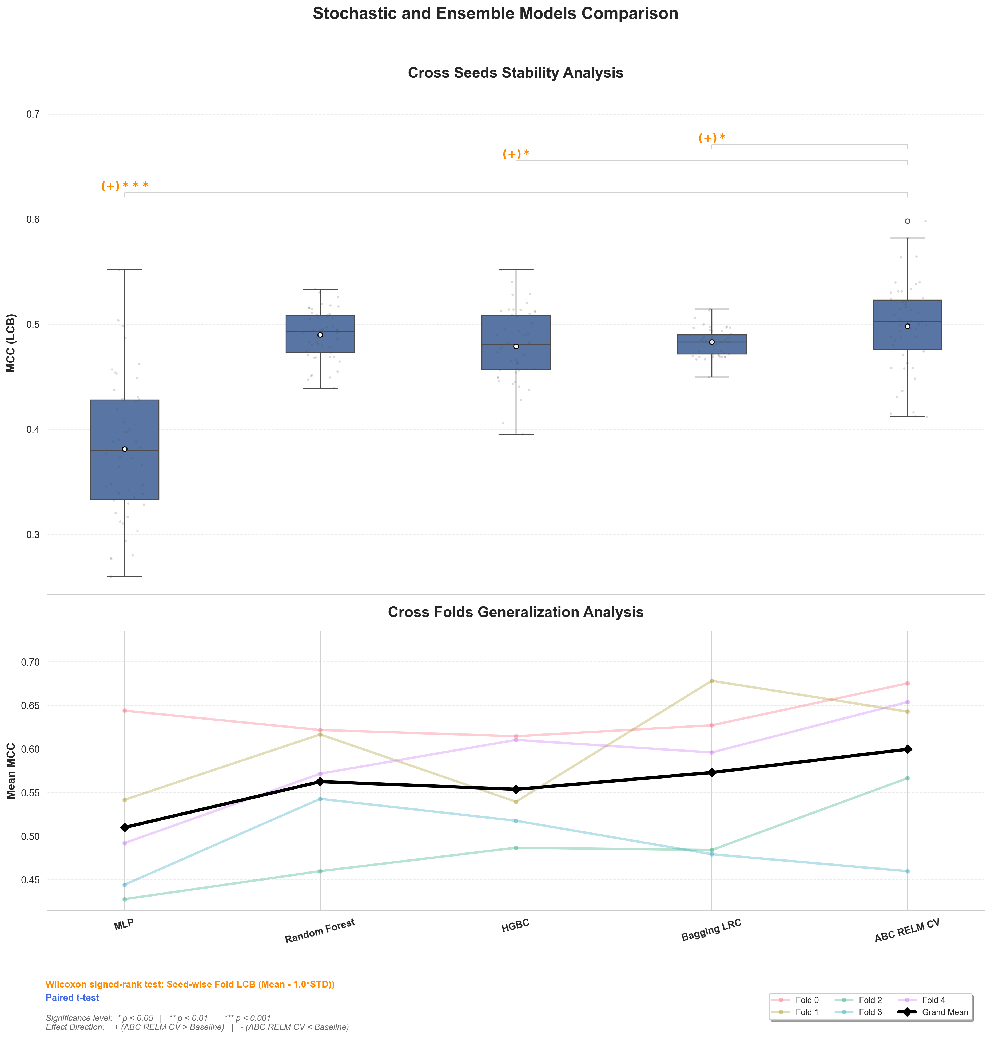
Model | Accuracy | F1-Score | MCC | P test | Direction
Stability (Metrics LCB with Wilcoxon signed-rank test)
MLP | 0.6826 ± 0.0351 | 0.6719 ± 0.0469 | 0.3811 ± 0.0657 | 1.0537 × 10⁻¹¹ | +1
Random Forest | 0.7446 ± 0.0115 | 0.7378 ± 0.0117 | 0.4899 ± 0.0231 | 0.7638 | 0
HGBC | 0.7382 ± 0.0164 | 0.7245 ± 0.0182 | 0.4790 ± 0.0332 | 0.0203 | +1
Bagging LRC | 0.7405 ± 0.0065 | 0.7249 ± 0.0079 | 0.4829 ± 0.0128 | 0.0323 | +1
ABC RELM CV | 0.7453 ± 0.0203 | 0.7169 ± 0.0225 | 0.4980 ± 0.0421 | - | -
Generalization (Metrics with paired t-test)
MLP | 0.7487 ± 0.0442 | 0.7394 ± 0.0420 | 0.5098 ± 0.0872 | 0.1435 | 0
Random Forest | 0.7804 ± 0.0326 | 0.7707 ± 0.0289 | 0.5625 ± 0.0661 | 1.0000 | 0
HGBC | 0.7756 ± 0.0286 | 0.7635 ± 0.0287 | 0.5537 ± 0.0569 | 0.6956 | 0
Bagging LRC | 0.7855 ± 0.0443 | 0.7732 ± 0.0473 | 0.5729 ± 0.0884 | 1.0000 | 0
ABC RELM CV | 0.7956 ± 0.0437 | 0.7741 ± 0.0491 | 0.5996 ± 0.0883 | - | -
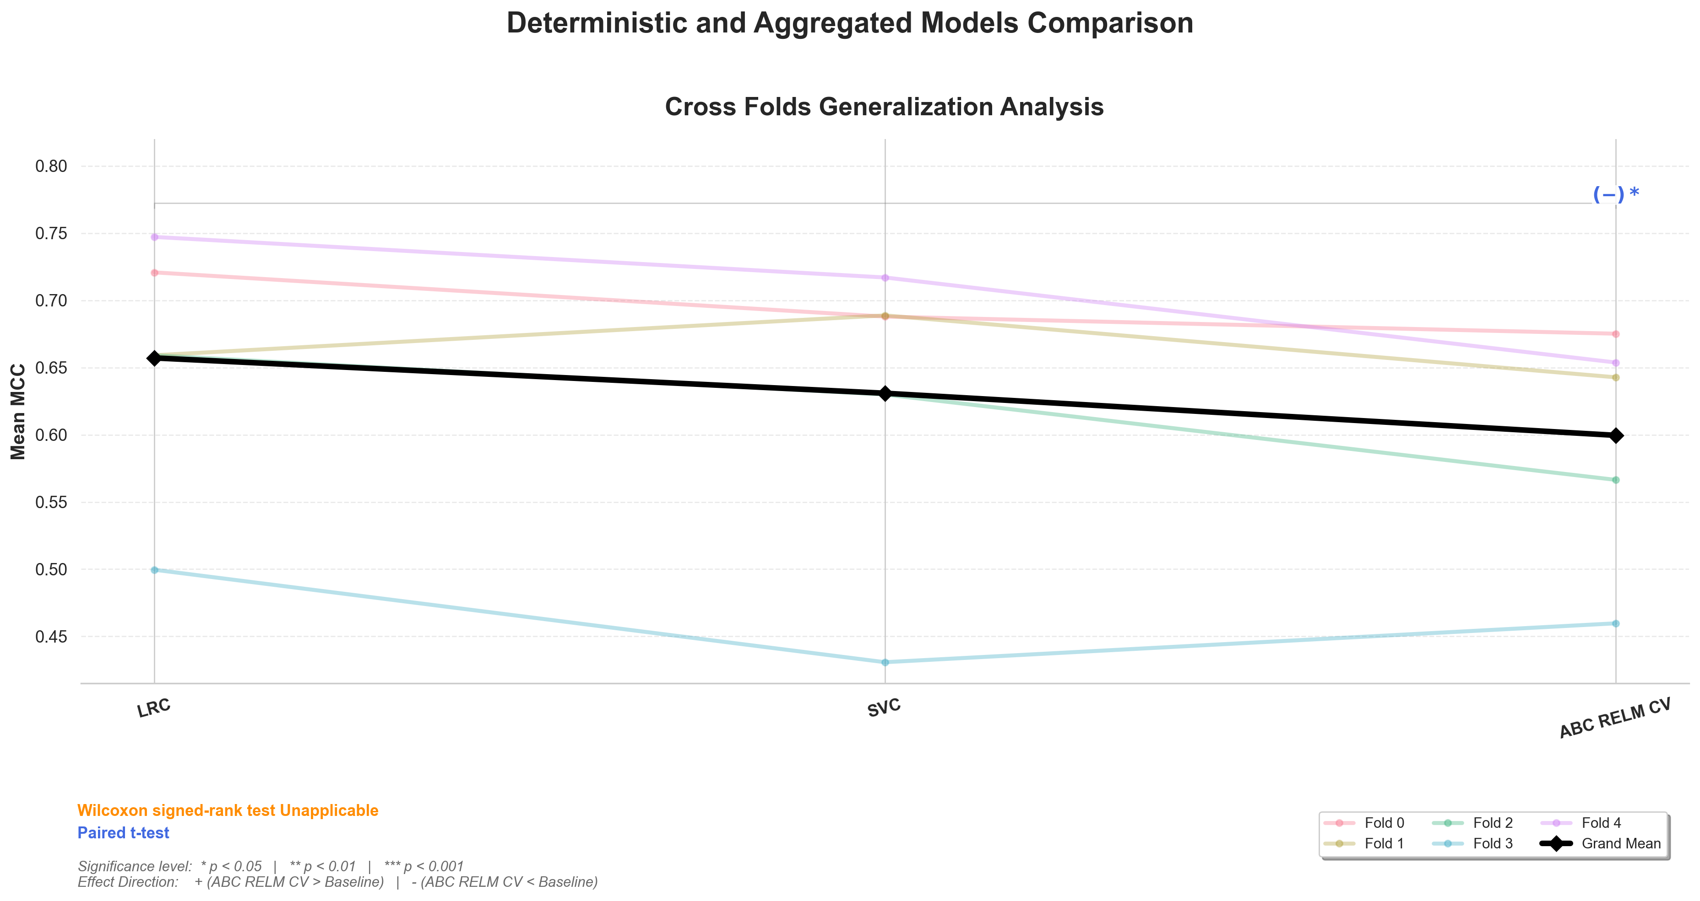
Model | Accuracy | F1-Score | MCC | P test | Direction
Generalization (Metrics with paired t-test)
LRC | 0.8269 ± 0.0493 | 0.8136 ± 0.0589 | 0.6572 ± 0.0962 | 0.0392 | -1
SVC | 0.8143 ± 0.0583 | 0.8018 ± 0.0652 | 0.6309 ± 0.1163 | 0.3021 | 0
ABC RELM CV | 0.7956 ± 0.0437 | 0.7741 ± 0.0491 | 0.5996 ± 0.0883 | - | -
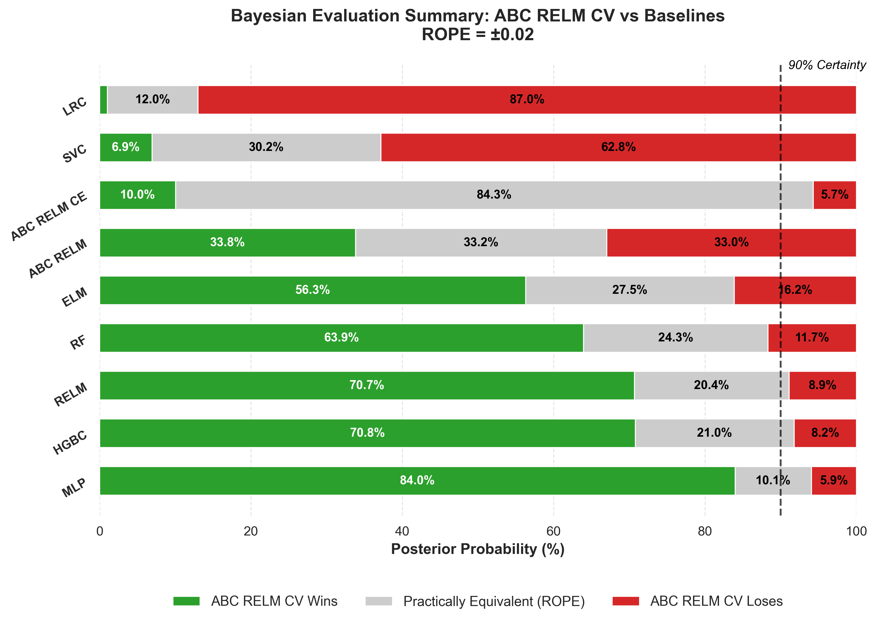
Model | Accuracy | F1-Score | MCC | P Win
ABC RELM CV | 0.7956 ± 0.0437 | 0.7741 ± 0.0491 | 0.5996 ± 0.0883 | -
LRC | 0.8269 ± 0.0493 | 0.8136 ± 0.0589 | 0.6572 ± 0.0962 | 0.0103
SVC | 0.8143 ± 0.0583 | 0.8018 ± 0.0652 | 0.6309 ± 0.1163 | 0.0691
ABC RELM CE | 0.7946 ± 0.0441 | 0.7728 ± 0.0493 | 0.5975 ± 0.0894 | 0.1002
ABC RELM | 0.7956 ± 0.0355 | 0.7750 ± 0.0403 | 0.5991 ± 0.0712 | 0.3381
ELM | 0.7823 ± 0.0310 | 0.7612 ± 0.0365 | 0.5720 ± 0.0616 | 0.5630
RF | 0.7804 ± 0.0326 | 0.7707 ± 0.0289 | 0.5625 ± 0.0661 | 0.6395
RELM | 0.7733 ± 0.0317 | 0.7532 ± 0.0347 | 0.5525 ± 0.0641 | 0.7068
HGBC | 0.7756 ± 0.0286 | 0.7635 ± 0.0287 | 0.5537 ± 0.0569 | 0.7078
MLP | 0.7487 ± 0.0442 | 0.7394 ± 0.0420 | 0.5098 ± 0.0872 | 0.8396

